**Bi-Weekly Report of (Team# 10 ) Week#14_**

<All teams will report their progress on Friday Starting from Week 5 (2020.04.10) >

**What were the goals for the last 2 weeks?**

< Enumerate your goals for the last 2 weeks. Be sure that your team goals are measurable and connected to your requirements. > Each member of the team should mention his goals individually.

**1. Enable Multi-Environment Access for the Minigame “Dimensional Reduction” Upon Readiness [Jongeun Park, Minseop Lee]**

- Ensure that once the Pixel 3D game is fully ready, it supports multi-environment access, allowing players from different platforms to join and interact seamlessly.

**2. Polish minigame “Dimensional Reduction”[Yiel Jang, Seunghwan Yang]**

* Instead of creating another minigame, polish the existing minigame “Dimensional Reduction”.
* Add more interactions
  + Shoot and stun mechanism(Player-Player)
  + Items with reward on the map(Player-Game)
    - Add speed, add score, etc.
  + Interactive map features(Player-Game)
    - Doors, Windows, moving stairs
* Add audio materials
  + Atmospheric sounds
  + Other audio effects when interaction happens.

**What goals were accomplished this week?**

< Enumerate what goals were completed. > Each member of the team should mention his goals individually.

**[Planned Goals]**

* Enable Multi-Environment Access for the minigame “Dimensional Reduction” Upon Readiness [Jongeun Park, Minseop Lee]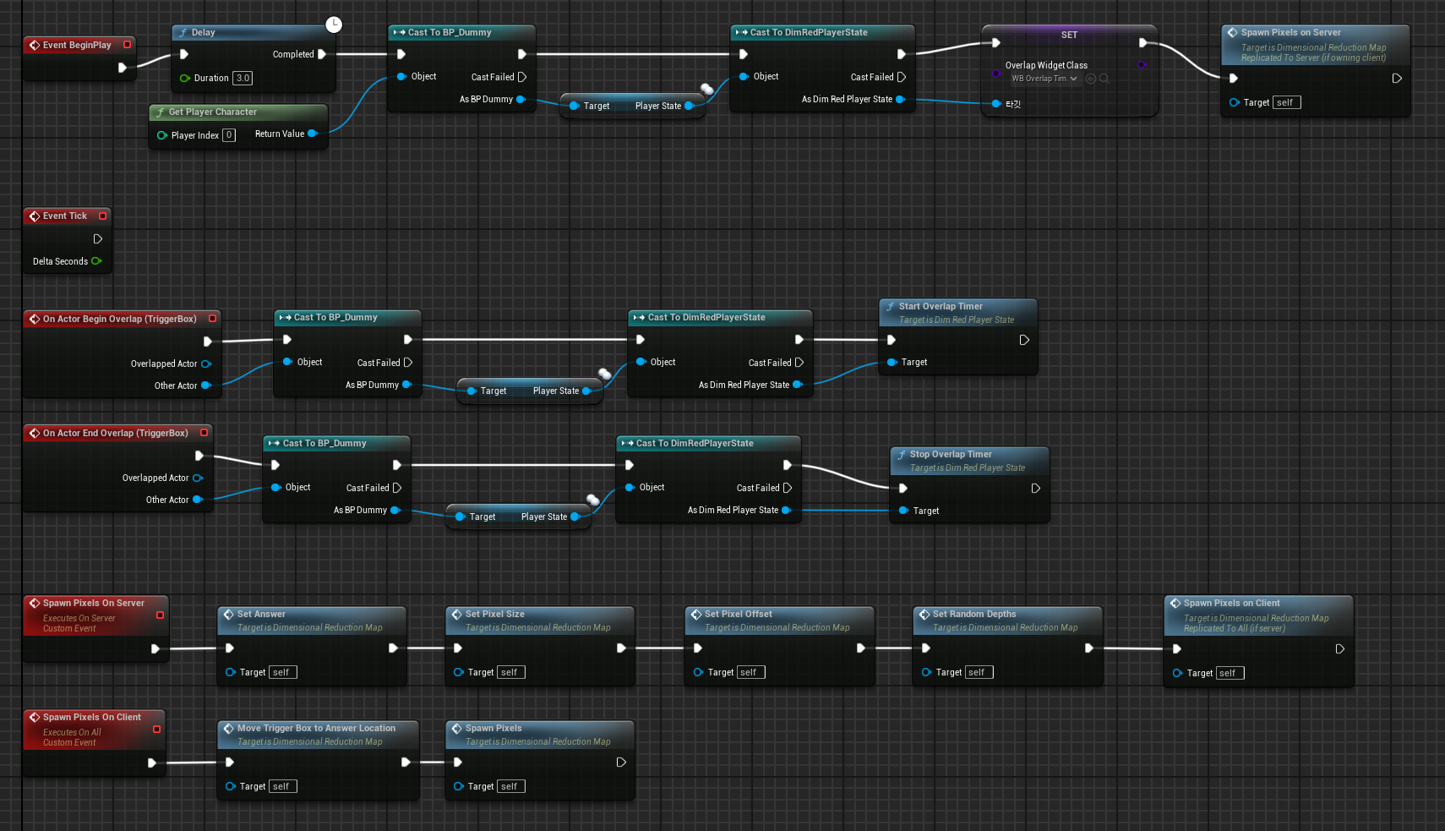
* Revised the replication logic for answer data to enhance the consistency of gamer experience in Dimensional Reduction.
* Fixed replication issues that guests cannot see the pixel actors and players are unintentionally started on different maps. To solve these issues, the blueprint nodes were moved from the blueprint ‘BP_PixelSpawner’ to the level-blueprint of Dimensional Reduction level.
* Polish Minigame “Dimensional Reduction” [Yiel Jang, Seunghwan Yang]
* Add background music and effect music
* Refined the logic for answer checking by calculating vector between sight view and origin
* Add items that change the player states using blueprint (e.g. speed, movability)
* 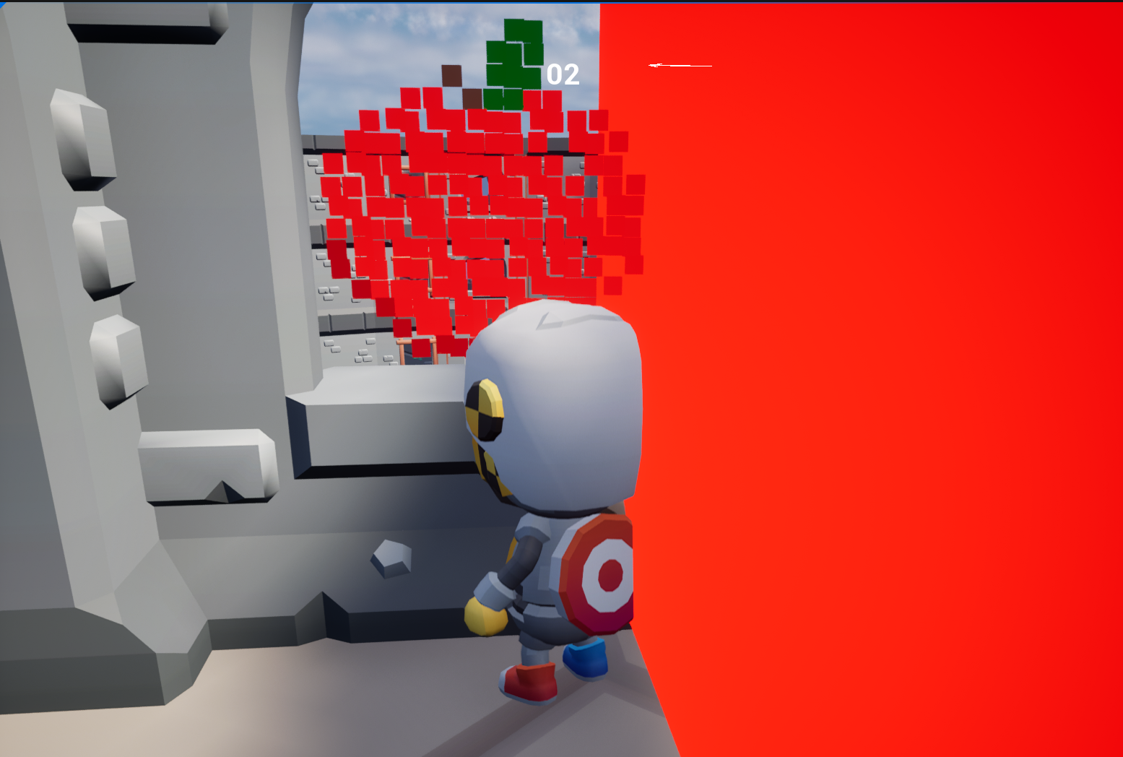

[Non-Planned Goals]

* Added ‘running’ feature [Yiel Jang]
  + Server stores each player’s is_running state information, and simulates it
  + when is_running, running animation is played(fixed unmatching animation with walking speed)
  + Players can now run when ‘shift’ is pressed. Otherwise, the speed of the character slows down.
  + Implemented with C++ codes

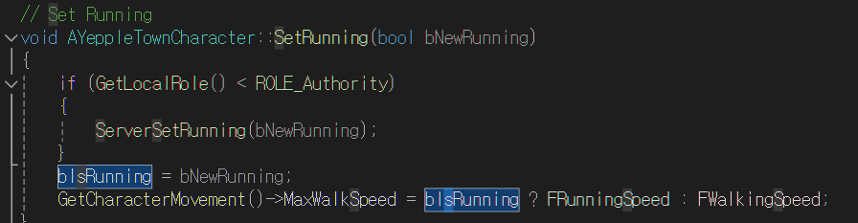

* Basework for character change[Yiel Jang]
  + Server stores each player’s mesh index and assigns corresponding mesh to each player when level is loaded and beginPlay() is called.
  + Interface for changing character mesh is implemented, and tested in multiplayer system
  + Further work should be conducted to fully integrate the feature within the system

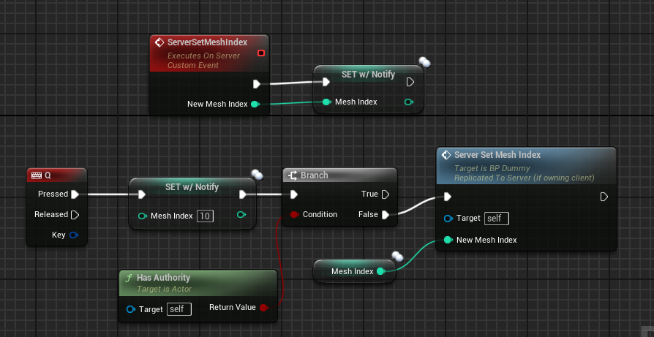

* Host and join lobby system improvements[Jongeun Park, Minseop Lee]
  + Improved level traveling logic using our plugin
  + use Unreal Engine Online Subsystem Interface using steam
  + add some delegates and custom delegates like OnCreateSession, OnDestroySession, OnJoinSession, OnFindSession
* Implemented trigger box and add timer UI for level traveling[Jongeun Park, Minseop Lee]
  + set up trigger box and implement level blueprint timer logic using timer handle structure
  + Build a timer manager and access it via AActor function called GettimerManager.
  + 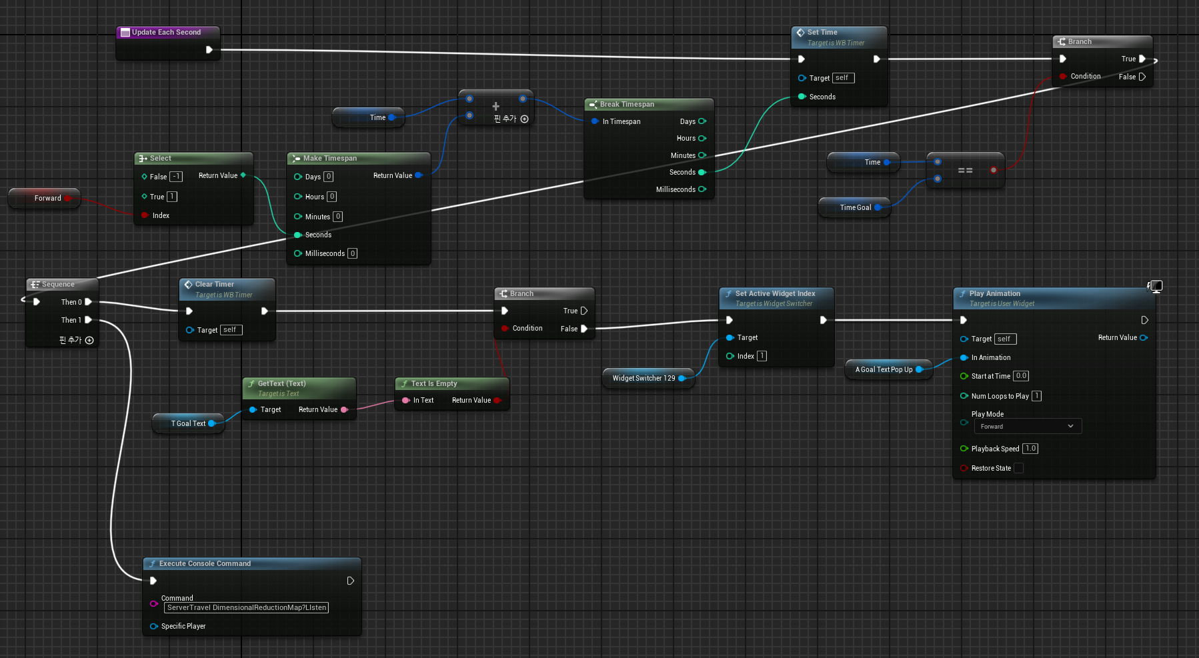

**Reflect critically on any goals not accomplished.**

< Explain why you did not complete any missed goals and what you plan to do moving forward with respect to these goals. > Each member of the team should mention his goals individually.

Each member of the team should mention his goals individually.

**1. Enable Multi-Environment Access for the Minigame “Dimensional Reduction” Upon Readiness**

- Objective: Ensure that once the Pixel 3D game is fully ready, it supports multi-environment access completely, allowing players from different platforms to join and interact seamlessly.

- Status: This goal was not fully accomplished. Although we have made progress in preparing the Pixel 3D game for multi-environment access, there are still integration issues that need to be resolved. Specifically, when traveling to Dimensional Reduction level from the lobby, cross-platform connectivity remains inconsistent, therefore there are issues about connection instability and further testing and debugging are required to ensure smooth interaction across different environments.

**2. Polish Minigame “Dimensional Reduction”**

- Objective: Instead of creating another minigame, focus on polishing the existing minigame “Dimensional Reduction” by adding more interactions, a shooting and stun mechanism, interactive map features, and audio materials.

- Status: Several critical interaction systems were not completed:

- Stun, Acceleration, Deceleration, and Shooting Mechanisms: These player-player interaction features were planned to enhance gameplay dynamics. However, we encountered technical challenges with the implementation, particularly with synchronization and performance issues.

- Polishing Timer System: Improvements to the timer system were aimed at providing better feedback and game pacing, but the enhancements were only partially integrated, lacking the final polish.

- Interactive Map Features: While some progress was made on adding doors, windows, and moving stairs, these features are not fully operational. Integration and collision detection issues delayed their completion.

- Audio Materials: Atmospheric sounds and other audio effects were not fully integrated. While initial sound design was completed, implementation into the game engine has yet to be finalized.

**What are the goals for next two weeks?**

< Enumerate your team goals for next 2 week. Be sure that your goals are measurable and connected to your requirements. > Each member of the team should mention his goals individually.

1. Multiplayer Lobby Design:

* Complete the UI design for the multiplayer lobby, including player lists, game settings and ready buttons.
* Implement the multiplayer matching system, ensuring that players can be matched efficiently and placed into lobbies.

2. Weapon System Development:

* Model and texture key weapons such as rifles and pistols, ensuring they are ready for in-game use.
* Create animations for weapon actions, including firing, reloading, and idle states.
* Implement the firing mechanism for weapons, including bullet trajectory, hit detection, and visual/audio effects.
* Develop the ammunition management system, including tracking ammo counts and implementing reload mechanics.

**How many hours were spent on each goal noted above?**

< For each person on the team list the goals they worked on including completed and non-completed goals

<That means each member should mention what exactly he have done to accomplish the goals of this week>

1. Enable Multi-Environment Access for the Minigame “Dimensional Reduction” Upon Readiness

- Team Members: Jongeun Park, Minseop Lee

- Total Hours Spent: 10 hours

- Implementation and Debugging: 10 hours

2. Polish Minigame “Dimensional Reduction”

- Team Members: All members contributed variously to different aspects of this goal

- Total Hours Spent: 19 hours

- Adding More Interactions: 10 hours

- Implementing Item Collision Detection: 6 hours

- Polishing Timer System: 4 hours

- Audio Materials: 4 hours

- Atmospheric Sounds: 2 hours

- Interaction Audio Effects: 2 hours

- Miscellaneous Polishing and Tweaks: 5 hours